Final Project Design Phase
Computer Science - Week 11
Oct 3, 2026 - Version 0.0.4

For complete instructions and project ideas, refer to the assignment in Canvas. Specifically, review the final project requirements before you continue below. If you have not reviewed the project requirements in Canvas (you might have to go to the modules view and check the current or past week's content), you will not be able to properly complete the parts below. In addition, it may be helpful to review the information on this Drafter documentation page.

0) Project Planning and Preparation
Successful programmers spend time planning before they begin coding. After reviewing the project requirements, answer the following questions to help guide your design and development process.
- What concepts from class or previous assignments might help you complete this project? Which programming concepts (loops, conditionals, lists, classes, etc.) do you expect to use? What programming skills do you want to improve while completing this project?
A lot of dataclasses and for loops are what i expect to use the most. And so because of that i need to improve my for loop coding. I also expect to make drafter calls like buttons and user inputs.

- Which parts of the project do you expect to be the easiest for you? The hardest? Why?
The easiest might be defining my dataclasses that i need to use and the hardest will be making everything into a drafter website.

- Even though you have not yet designed the final project, estimate which tasks will likely require the most time and effort? Which features or components should be implemented first?
Firstly i should make the reaction dataclass and make the balanced reaction checker to make sure the user inputs a balanced reaction. The tasks that will take the most time and effort would be building the drafter pages like the home page and reaction calculator page.

- What distractions might interfere with your work and how will you minimize them? What resources will you need available while working? What questions, if any, do you still have about the assignment requirements?
Distractions will be other schoolwork and i will just have to get them done in conjunction to this project. Resources id need would be github to understand already created code functions and to translate them over to my code, and tools in thonny like chempy and numpy

1) Site Diagram
Create a mock-up of your planned website. We suggest you make the mockup on paper, although you can also use software like PowerPoint or Slides to make a mockup. There is other design software that could also be used, but we strongly encourage you to keep it simple. Do not spend more than 15-30 minutes detailing the mock-up. Your goal should be to make a very quick and dirty diagram, to show that you have some kind of idea.

We recommend drawing each page as a rectangle, and laying out the text, buttons, and other components inside. Then, use arrows to indicate links between pages. Label each page the way you will name each function, and then put labels on the arrows to indicate what the button links. Also write down any parameters that should come into the pages.

In addition to the pages and routes, write down what fields your `State` will have, both their names and types. Think clearly about what data will need to be persistent across the entire website.

Add photo(s) or screenshot(s) of your website mock-up and labeled diagram on the next page.

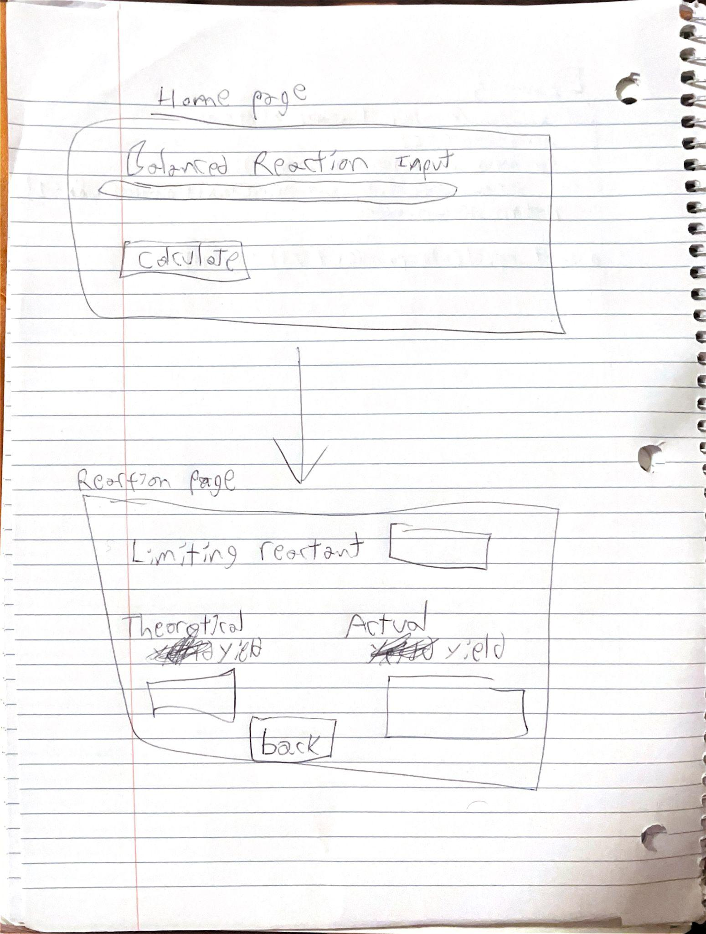I should only have two dataclasses

But for the State dataclass the fields it contains should correspond to the current information to be shared between pages. Those fields would be something along the lines of current_equation: str, current_reaction: Reaction, reaction_history: list[Reaction], actual_yield: float, calculation_count: int, and error_message: str
Then to fill in for the reaction type fields, i will make a Reaction dataclass with the fields, equation: str, reactants: list, products: list, balanced: bool, limiting_reactant: str, theoretical_yield: float, and the actual_yield, float

2) Implementing Requirements
This table should serve as a draft for how you will implement the requirements into your final project. You may change your ideas later on, but your final site must fulfill all the requirements.

Requirement | Implementation
Purpose/Functionality  A 1-2 sentence description of the purpose or functionality of your site | Users input balanced reaction, computer outputs limiting reactant, actual yield, and theoretical yield.
State Dataclass Attributes  Minimum of 4 attributes, one of which must be a list/dict of instances of your second dataclass.  Briefly describe each attribute, its type, and how it will be meaningfully modified throughout the site. | current_equation : str, stores chemical equation entered by user and can be modified when user changes input.  Current_reaction: Reaction, stores current chemical reaction and calculated information. Will be updated when user inputs new reaction.  Reaction_history: list[Reaction], stores list of previously completed chemical reactions as instances of reaction dataclass.  Error_message: str, stores error messages when the user enters unbalanced equation.
Second Dataclass  Your second dataclass, including its attributes, their types, and how they will be meaningfully modified (if they are modified) | Equation: str, stores the complete chemical equation entered by the user.  Reactants: list, stores reactants in chemical equation, including their formulas, starting masses and coefficients provided by chempy.  Products: list, stores products in the chemical equation with their formulas and coefficients.  Limiting_reactant: str, stores formula or name of the reactant that runs out first. Can be assigned after program compares available mole ratios of reactants.
Routes (minimum 7)  The names of your route functions | home(), calculator(), calculate_results(), results(), history(), reaction_details(), info_page(), about()
Pages (minimum 5)  A brief description of the pages in your site | Home page, results page, help/instructions page, balanced reaction input page, reaction details page.
User Input (minimum 3)  Description of user input components (TextBox, TextArea, CheckBox, or SelectBox) and their purposes  For more information on these input types, see Drafter Documentation. | One textbox for the chemical equation input, one for the reactant masses, and one for the actual yield the user measured. They should all be textboxes.
If Statements (minimum 3)  Brief description of what will be evaluated in your if statements and how they will meaningfully change the logic of the site | If equation is balanced: computer checks if eq is balanced and returns error if False.  If actual yield was entered: if user enters actual yield computer will calculate percent yield but if not the computer will only calculate theoretical yield.  If valid masses entered: if reactant masses and actual yield are positive numbers.
Loop (minimum 1)  This loop must iterate over the list/dict of dataclass instances in your State attribute.  Description of this loop and why it is meaningful to the site | Saved reaction calculations: computer will iterate through lists of reaction dataclass instances stores in state attribute and for each reaction it will display saved information as history. So that calculations dont have to be repeated if running multiple.

LLM Conversation
If you used an LLM in any part of this work, copy and paste every part of that conversation below. Otherwise, you may be given a zero for the assignment. Obviously, these words will not all be yours, and this is the exception to the requirement at the top of this assignment that all responses be in your own words. If you did not use an LLM to assist you in this assignment, simply say so below.
What should my loop do, and how can it be meaningful to my Chemical Reaction Calculator?
Answer: My loop can iterate through a list of Reaction dataclass instances stored in my program's State. It will display the results of each calculation, including the chemical equation, limiting reactant, theoretical yield, and actual yield. This is meaningful because users can view multiple calculations without having to repeat them.
Do I need a separate History page for this loop?
Answer: No. I can display the saved calculations directly on my Results page. The program can use a for loop to go through the list and display each reaction's information.
Why is this loop important for the assignment?
Answer: The assignment requires at least one meaningful loop that iterates over a list or dictionary of dataclass instances stored in State. This loop satisfies that requirement while also giving the calculator a useful feature.

Final Submission
When you are finished, download this file as a Word Document (docx) and upload the file to the appropriate assignment on Canvas.

